21st January 2019

**Meritorious finish for YOKOHAMA in the Dakar Rally**

The YOKOHAMA clad Ssangyong Rexton DKR of Oscar Fuertes and Diego Vallejo of the Ssangyong Motorsports team managed a hard-earned podium in their car category.

This was a distant goal for the Spanish duo, when the first stage of the Dakar 2019 kicked off on 7th January. Ten days later, however, Fuertes and Vallejo met their objective of returning to the Peruvian capital after 3,000 timed km’s and a total running time of 63 hours, 14 minutes and 19 seconds. For a second year in a row, the Spanish crew has succeeded in finishing the Dakar with SsangYong Motorsport and on YOKOHAMA Geolandar M/T G003 tyres. Their outstanding third position in their class for the Rexton DKR, which is even more remarkable – if possible – given this edition’s gruelling conditions that added some heroic actions in their performance.

The tenth and last stage has taken the survivors from an initial group of over a hundred cars through a 112-kilometre special from Pisco to Lima. The Madrid-born driver and his Galician co-driver completed the stage in just under two hours, finishing in an excellent 29th position that secured them the 3rd place in the T1.3 class (rear-wheel-drive petrol-powered cars) and 33rd overall.

“The rally has been extremely tough and intense. It was not only about racing because driving through the places we had to was a real challenge”, assured Oscar Fuertes as he caressed the front of his vehicle: “Our SsangYong Rexton has brought us here despite everything we put it through.” He exclaimed delighted. When celebrating the success, the former Spanish Gravel Rally champion also wanted to thank the Korean brand’s team for their great job. “We should feel very satisfied with the work done. Everybody has given their 140%. Every single member of the team has been very passionate. Although today we are the protagonists and it is us who will be on the picture, we’ve all done a great job”, he concluded.

Meanwhile a spokesman for YOKOHAMA Europe expressed satisfaction with the performance of the Ssangyong team in the rally and offered congratulations on behalf of all at YOKOHAMA for the meritorious effort and great result achieved by Fuertes and Vallejo.

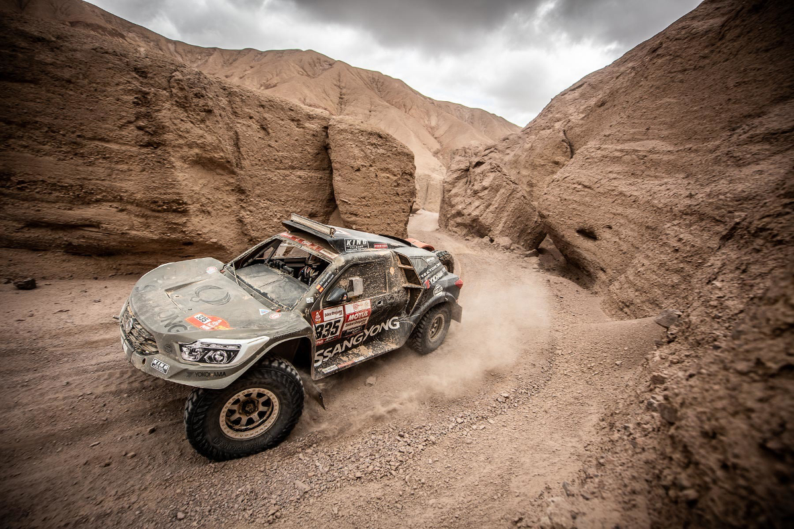

*A Gruelling Dakar pic Ssangyong Motorsport*

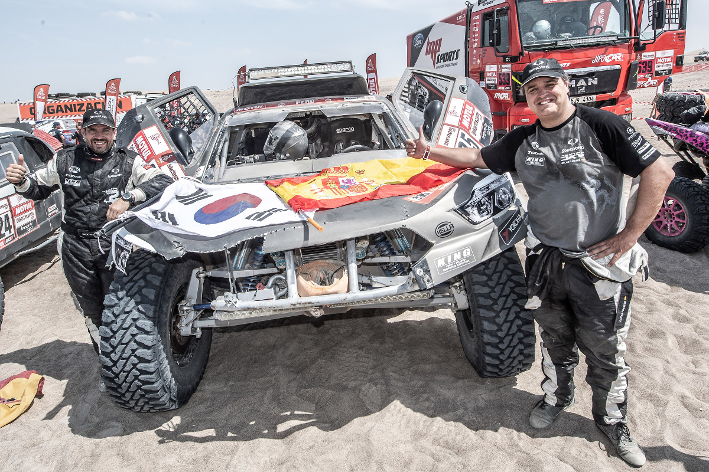

*Dakar 2019 Fuertes and Vallejo all smiles after completing the Rally*

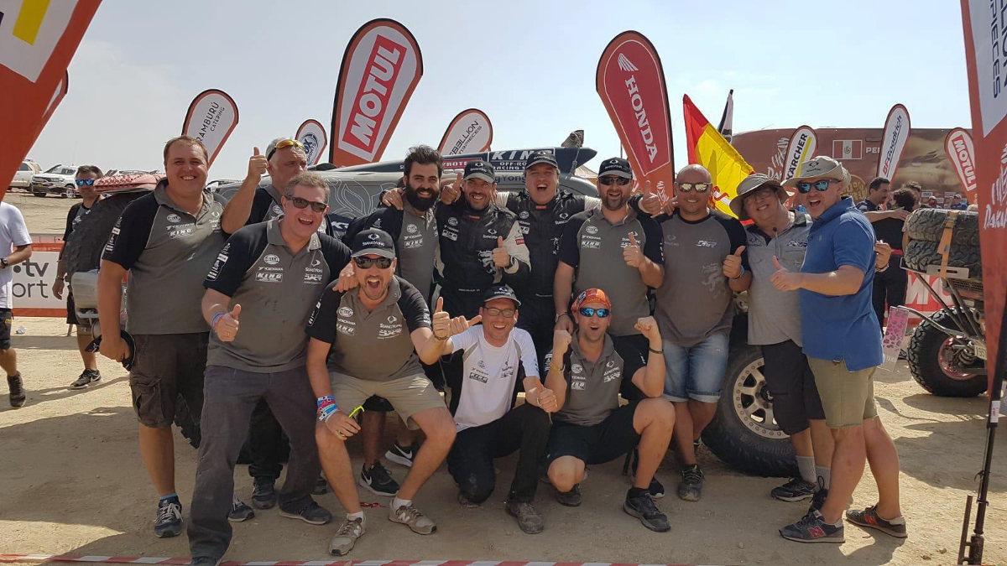

*Dakar19_Final Oscar Fuertes and a delighted Team*